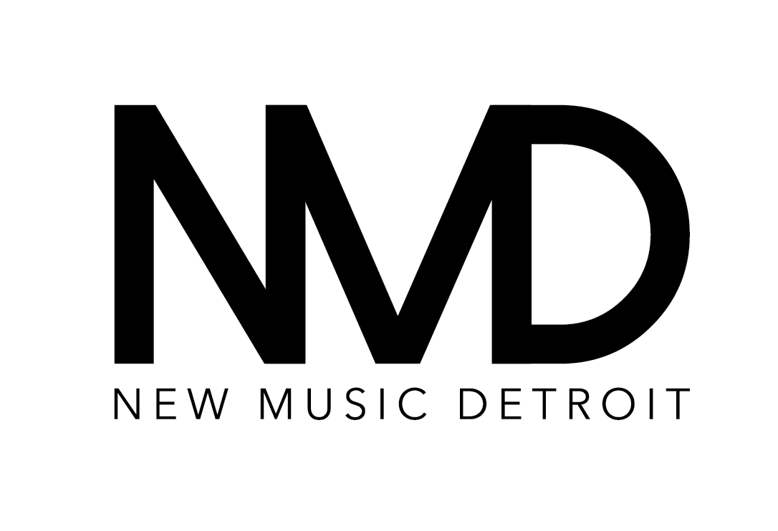

FOR IMMEDIATE RELEASE
OCTOBER 6, 2014

DETROIT NEW MUSIC FANS TO GET EXPANDED “STRANGE BEAUTIFUL MUSIC” MARATHON

DETROIT, MI – New Music Detroit will expand “Strange Beautiful Music,” a daylong marathon concert in mid-September spotlighting challenging and dynamic new music from late 20th century through today, thanks to John S. and James L. Knight Foundation.

Curated by New Music Detroit, the festival spotlights prominent Detroit musicians as well as guest artists from around the world. Past artists and collaborative composers include Todd Reynolds, Frank Pahl, Shara Worden, Evan Ziporyn, Marc Mellits, Bill Ryan, Virgil Moorefield, Nico Muhly, Slither, Apetechnology, UofM Percussion Ensemble, Latitude 49 and GVSU New Music Ensemble among others. With challenge funding from the foundation’s Knight Arts Challenge, Strange Beautiful Music will take place at the Max M. Fisher Music Center, home to the Detroit Symphony Orchestra and offering additional seating and an opportunity to grow and diversify the event’s audience.

“In a city with a rich musical legacy, New Music Detroit provides a platform for pushing the boundaries of contemporary music and offering audiences challenging new works,” said Dennis Scholl, vice president of arts for Knight Foundation, whose challenge aims to fund the best ideas for engaging and enriching the city through the arts.

About New Music Detroit
New Music Detroit (NMD), founded in 2006, is a collective of musicians dedicated to performing groundbreaking musical works from the late-20th century to the present day. A highly flexible ensemble with a cast of core members and prominent guest artists, NMD performs new and adventurous classical music in a wide variety of settings, for a wide variety of people. NMD strives to collaborate with the most exciting creative voices of our time and regularly gives performances of rarely heard works by today's major composers.
Through innovative programming and risk-taking, virtuoso performances, NMD continues to explore new ways of bringing the best of new and experimental music to the City of Detroit.

About John S. and James Knight Foundation
Knight Foundation supports transformational ideas that promote quality journalism, advance media innovation, engage communities and foster the arts. The foundation believes that democracy thrives when people and communities are informed and engaged. For more, visit KnightFoundation.org

Contact: New Music Detroit, Shannon Orme (248)497-5751, shannon.orme@gmail.com.

